Project 1: Network Security Fundamentals and FortiGate Integration
Week 3 Report: FortiGate Policies and NAT
Submitted to: Digital Egypt Pioneers Initiative (DEPI)
Team Members:
- Marawan Mohamed Abdelfattah Farag – Lead Configuration & Documentation
- Omar Mohamed Abdelrahman El-Sayed Amer – Technical Review
- Noor Hussain Mwafi – Project Planning & Task Structuring
- Abdullah Ashraf Saber – Testing & Connectivity Validation
- Mazen Mohamed Fathy – Environment Setup Assistance & Support

1. Executive Summary
The objective of Week 3 was to advance the security posture of the FortiGate firewall by implementing comprehensive network address translation (NAT) and fine-grained access control policies. The team successfully configured Source NAT (SNAT) for outbound traffic, established Destination NAT (DNAT) using Virtual IPs (VIP) for secure inbound access (e.g., SSH), and defined security policies to manage specific traffic flows, ensuring the environment is robust and ready for further security integration.

2. Environment Overview
The lab environment utilized the FortiGate VM deployed in Week 2:
- WAN Interface (port1): Dynamic IP (e.g., 192.168.152.x) connected to the VMware NAT network.
- LAN Interface (port2): Static IP (10.10.10.1/24) connected to the internal Host-Only network.
- Internal Server: A test endpoint (10.10.10.2) was deployed to validate inbound services.

3. Network Address Translation (NAT) Implementation
Objective: Implement SNAT for internal-to-external communication and configure DNAT for inbound service exposure.
3.1 Source NAT (SNAT) Verification
- Goal: Ensure all internal traffic (10.10.10.0/24) is translated to the firewall's WAN IP upon exit.
- Procedure: The existing Internet-Access policy (LAN WAN) was verified to have the NAT option enabled and set to "Use Outgoing Interface Address."
- Verification: Outbound traffic from the LAN Host (10.10.10.2) was confirmed to reach the internet.
  - Log Check: Logs confirmed that the original source IP (10.10.10.2) was successfully translated to the port1 IP (e.g., 192.168.152.130).
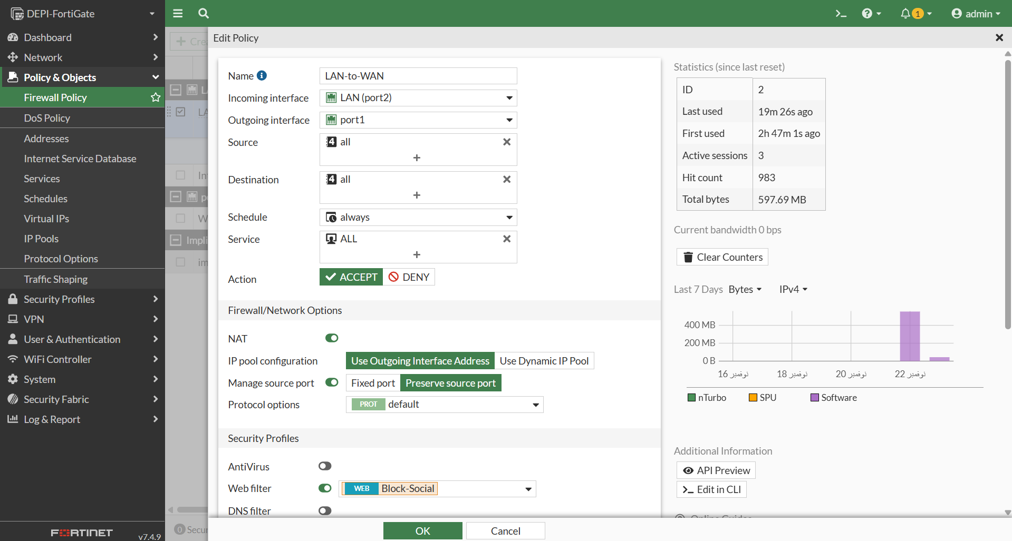

3.2 Destination NAT (DNAT) / Virtual IP Configuration
- Goal: Allow secure external access to the internal service (e.g., SSH on the internal server 10.10.10.2).
Step | Configuration | Details
1. Create Virtual IP (VIP) | Policy & Objects Virtual IPs | Name: SSH-Server-VIP  Interface: port1  External IP: 192.168.152.130 (FortiGate WAN IP)  Mapped IP: 10.10.10.2  Port Forwarding: Enabled (TCP/2222 22)
2. Create DNAT Policy | Policy & Objects Firewall Policy | Incoming: port1  Outgoing: port2  Source: all  Destination: SSH-Server-VIP  Service: SSH  Action: ACCEPT  NAT: Disabled
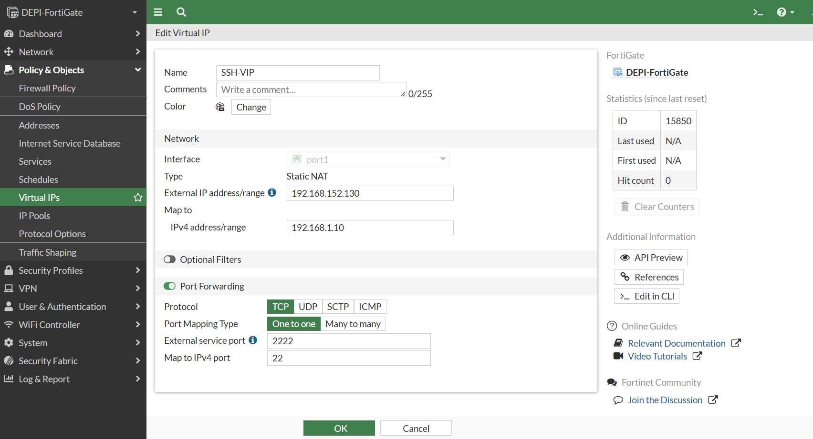
Screenshot 1:

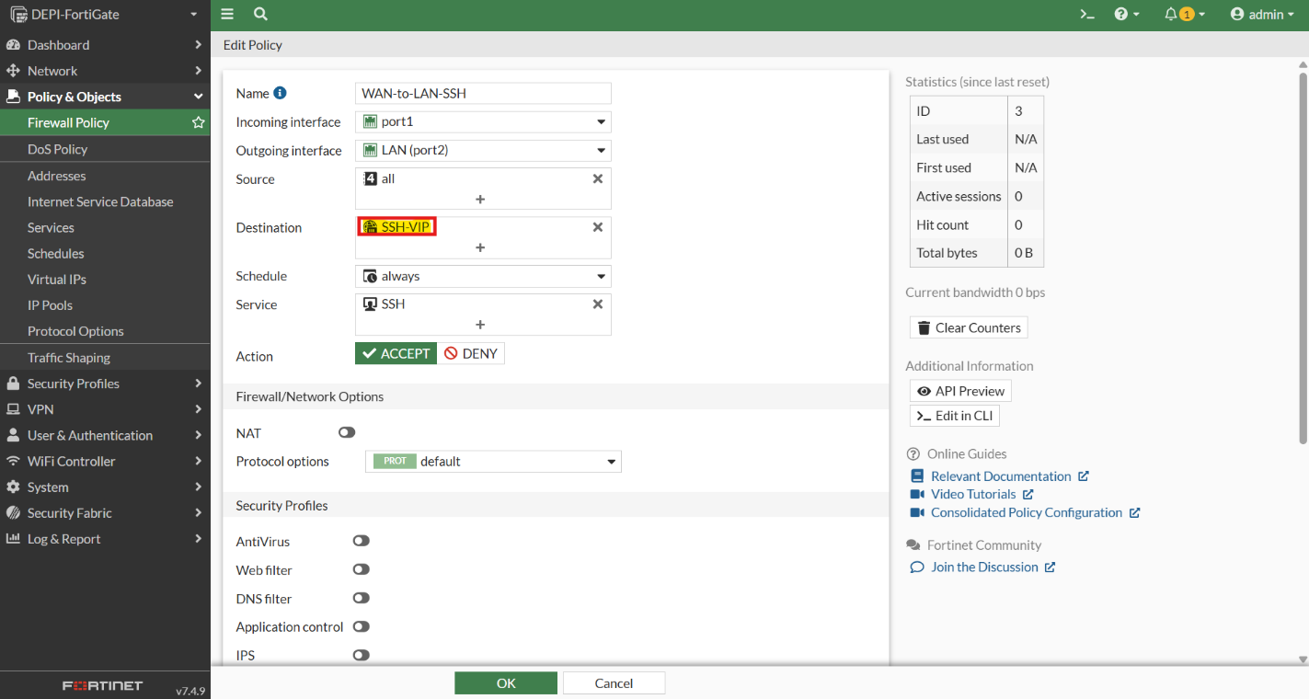

Screenshot 2:

4. Policy-Based Access Control
Objective: Implement a specific access policy to demonstrate granular traffic control and security filtering.
4.1 Granular Internet Access Policy
- Goal: Restrict general internet access to specific services (e.g., only HTTP/HTTPS) to enforce the principle of least privilege.
- Procedure: A new policy, LAN-Web-Only, was created (LAN WAN, Source: All, Destination: All) but restricted the Service field to include only HTTP and HTTPS.
- Verification: The LAN host could browse the web but was prevented from using services like FTP or Telnet via this specific policy.
Screenshot:
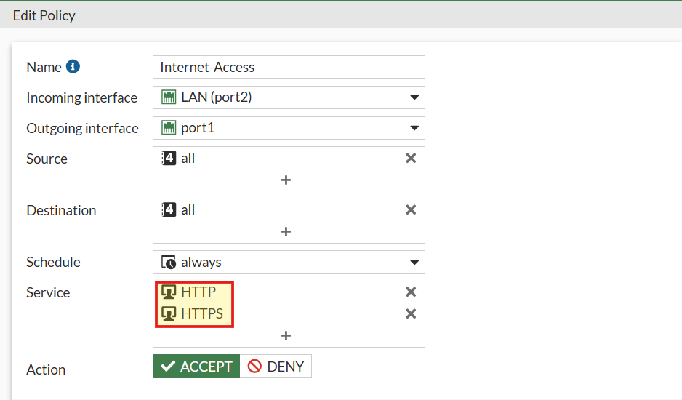

4.2 Web Filtering Implementation
- Goal: Apply a security profile to block access to specific content categories (e.g., Social Media).
- Procedure:
  - A Web Filter Profile (e.g., Block-Social) was created, enforcing a block on the "Social Networking" category.
  - The existing LAN-Web-Only policy was edited to enable the Web Filter security profile and assign Block-Social.
Screenshot 1:
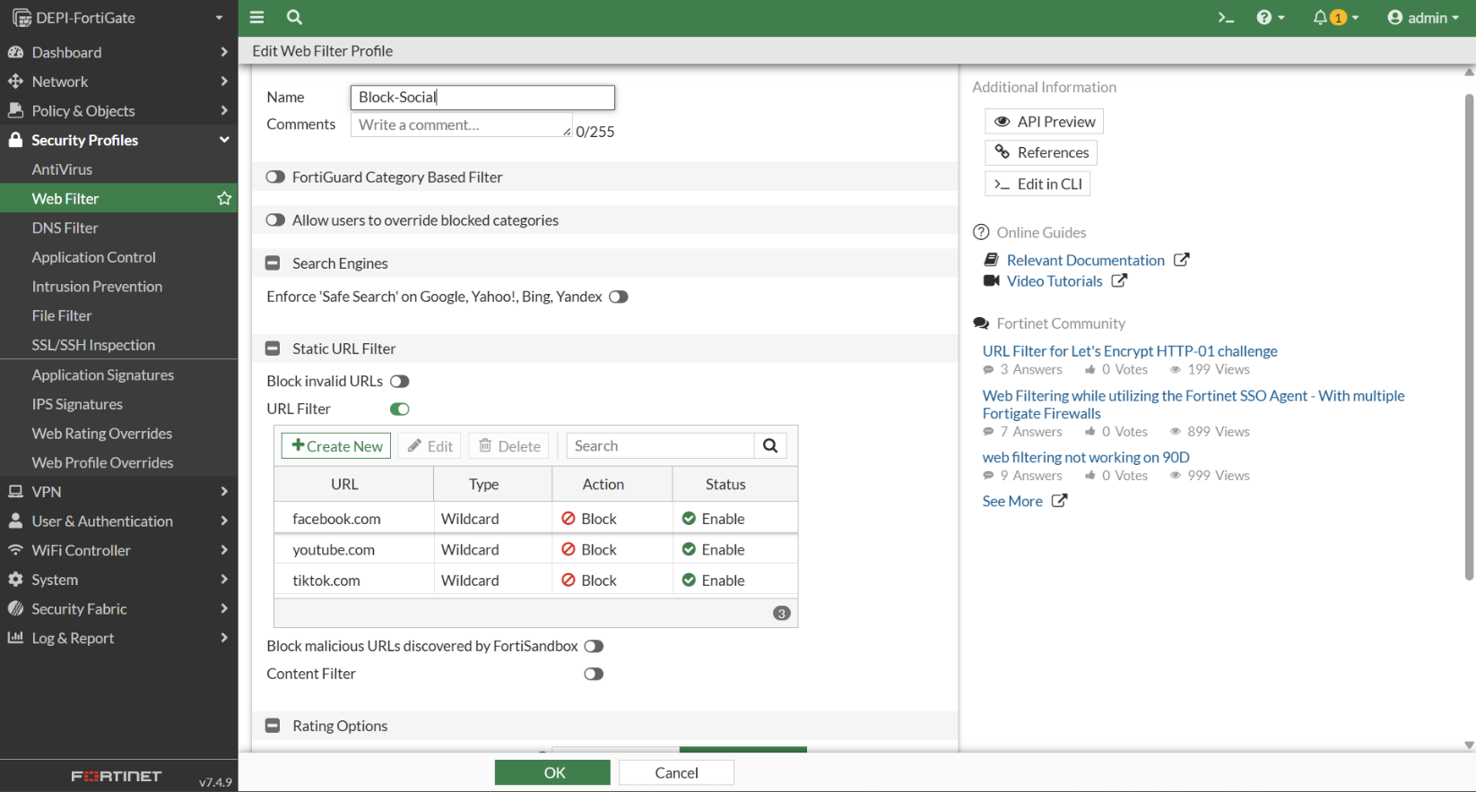
Screenshot 2:
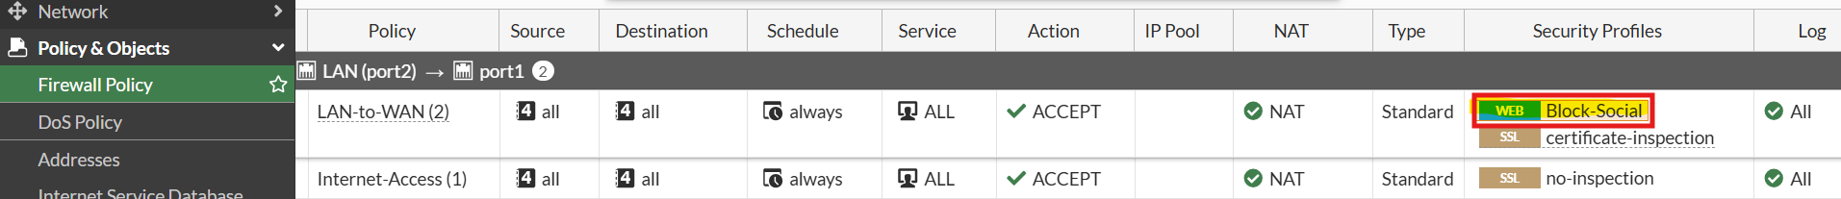

5. Test Results and Validation
Objective: Validate the implemented NAT configurations and security policies.
5.1 Source NAT (SNAT) Test
Test Case | Procedure | Expected Result | Actual Result
Outbound Connectivity | Browse any website from the LAN Host (10.10.10.2). | Successful web page load. | Successful.
Log Validation | Check FortiGate Traffic Logs. | Source IP 10.10.10.2 is translated to 192.168.152.130. | Confirmed.

Screenshot:
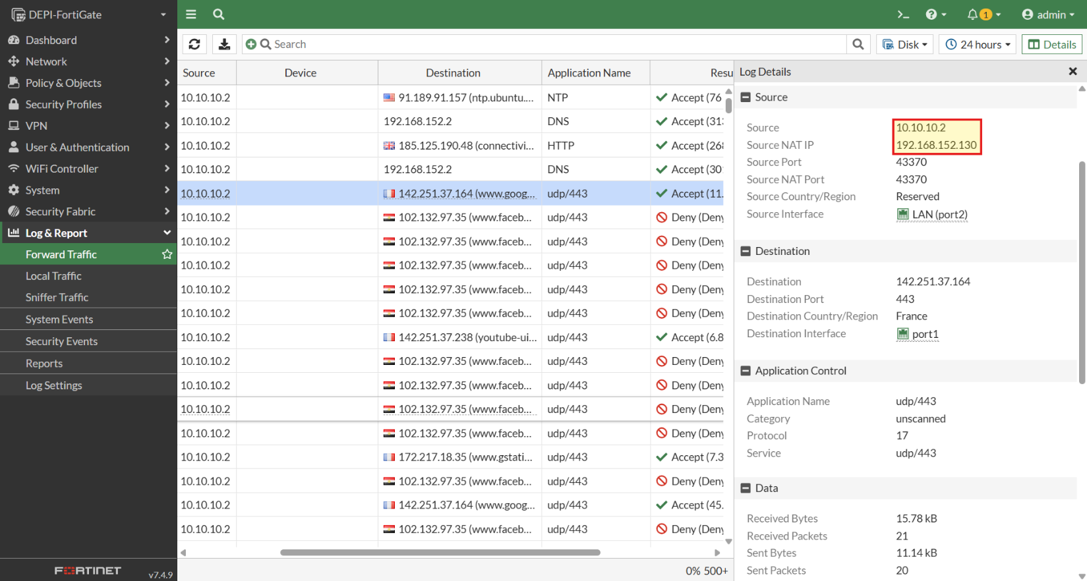

5.2 Destination NAT (DNAT) Test
Test Case | Procedure | Expected Result | Actual Result
Inbound Service Access (SSH) | Attempt SSH connection from the Host PC to the WAN IP (192.168.152.130). | SSH client successfully connects and displays the login prompt for the internal server (10.10.10.2). | Successful.
Log Validation | Check FortiGate Traffic Logs. | Destination IP 192.168.152.130 is translated to 10.10.10.2. | Confirmed.

5.3 Web Filtering Test
Test Case | Procedure | Expected Result | Actual Result
Content Block | Browse a social media site (e.g., facebook.com) from the LAN Host (10.10.10.2). | FortiGate block page appears. | Successful.

Blocked websites like Facebook:
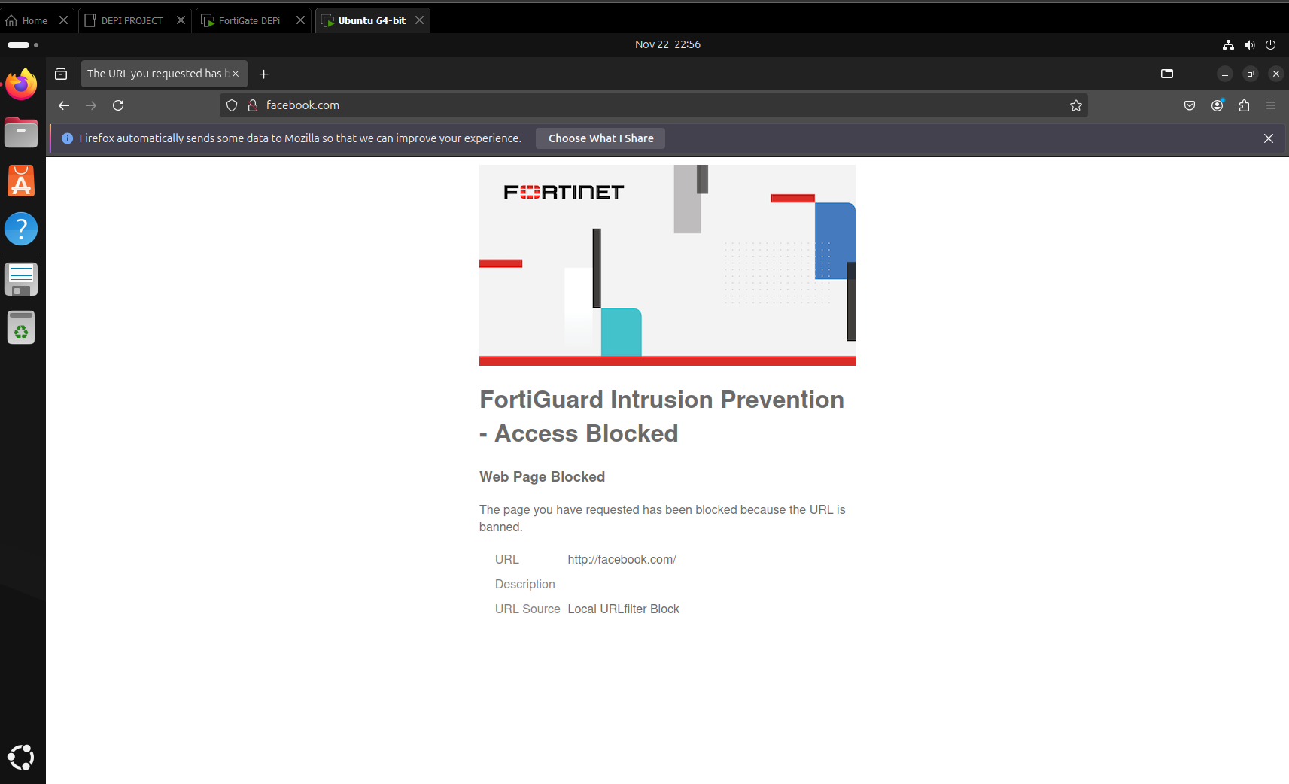

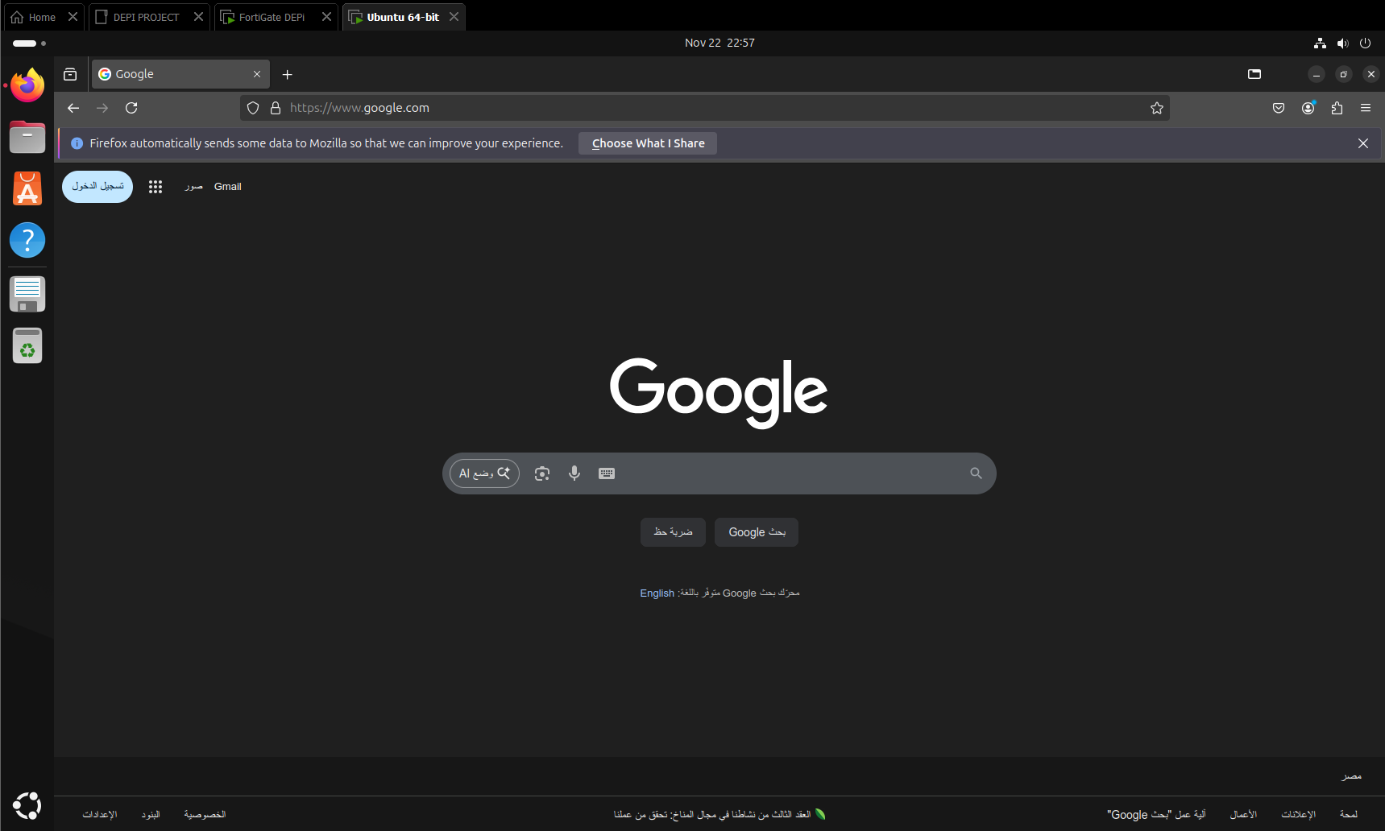
Other websites are normally allowed like Google:

6. Conclusion
The objectives for Week 3 were achieved with full functionality verified. The implementation of robust SNAT, critical DNAT for secured service exposure, and granular firewall policies successfully demonstrates the core capabilities of the FortiGate NGFW as a perimeter defense. The environment is now fully configured for advanced security integration and the final reporting phase.

